BDA Subsystems: The BDA Subsystems tab holds the list of eligible CNH BDA subsystem codes for use in BDA-type orders.

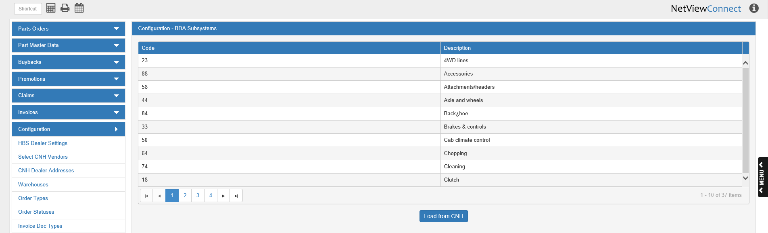

Code: This column shows the subsystem code.

Description: This column explains what the code stands for.

Load from CNH: When you first open CNH Connect (CSPS), you will need to click this button to load the subsystem codes from CNH. Otherwise, you will not be able to use them when processing BDA orders. After the button’s first use, the list will automatically reload every 30 days, but you can click the button at any point to load the most updated version of the list.

